Project Design Phase-II

Data Flow Diagram & User Stories

|  |  |
| --- | --- |
| Date | 18 October 2022 |
| Team ID | PNT2022TMID16344 |
| Project Name | SKILL AND JOB RECOMMENDER APPLICATION |
| Maximum Marks | 4 Marks |

# Data Flow Diagrams:

A Data Flow Diagram (DFD) is a traditional visual representation of the information flows within a system. A neat and clear DFD can depict the right amount of the system requirement graphically. It shows how data enters and leaves the system, what changes the information, and where data is stored.

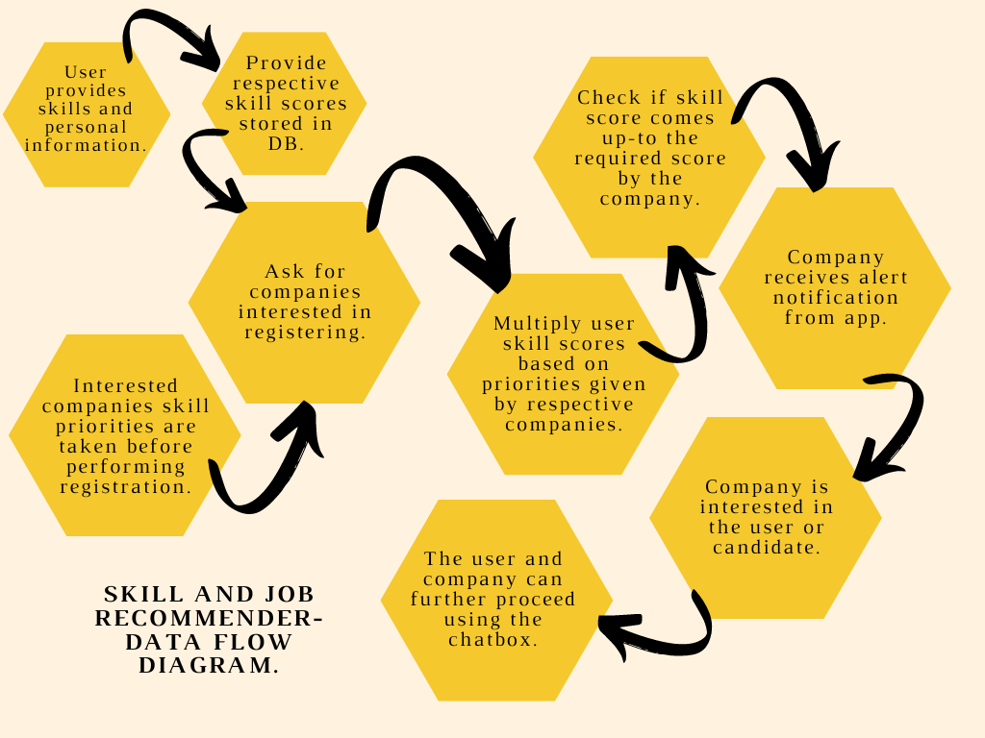

# User Stories

Use the below template to list all the user stories for the product.

|  |  |  |  |  |  |  |
| --- | --- | --- | --- | --- | --- | --- |
| **User Type** | **Functional Requirement**  **(Epic)** | **User Story Number** | **User Story / Task** | **Acceptance criteria** | **Priority** | **Release** |
| Customer (Mobile user) | Registration | USN-1 | As a user, I can register for the application by  entering my email, password, and confirming my password. | I can access my account / dashboard | High | Sprint-1 |
|  |  | USN-2 | As a user, I will receive confirmation email once I have registered for the application | I can receive confirmation email & click confirm | High | Sprint-1 |
|  |  | USN-3 | As a user, I can register for the application through Linkedin | I can register & access the dashboard with Linkedin  Login | Low | Sprint-2 |
|  |  | USN-4 | As a user, I can register for the application through Gmail | I can register and access the dashboard with G mail  login | Medium | Sprint-1 |
|  | Login | USN-5 | As a user, I can log into the application by entering email & password | I can access the dashboard | High | Sprint-1 |
|  | Search | USN-6 | As a user , I can search for the desired companies | Companies related to the search terms are listed | High | Sprint-2 |
| Customer (Web user) | Apply | USN-7 | As a user , I can apply for a company | Application is submitted to the company | High | Sprint-2 |
|  | Review | USN-8 | As a user, I can review the company | Review is listed on the company profile | Medium | Sprint-2 |
| Admin | Forward | USN-9 | As a customer care executive , I must forward the applications to the respective company | The application is received by the company | High | Sprint-1 |
|  | Send confirmation | USN-10 | Confirmation mail is sent from the respected company | Confirmation is received by the user | High | Sprint-2 |
|  | Manage review | USN-11 | As an admin , I must make the reviews appear on the company’s profile | Reviews appear on the company’s profile | Low | Sprint 2 |